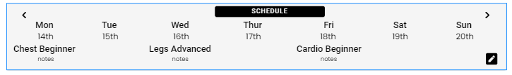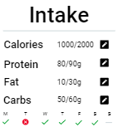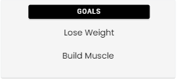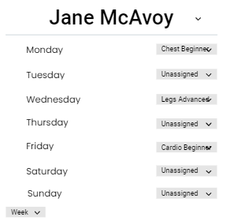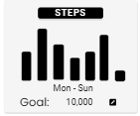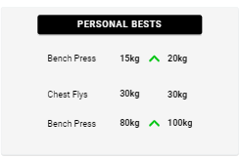 Importance Ranking

Reasons:

Very important for catchup meetings and would save time

Reasons:

Extremely important for a clients progression

Reasons:

Said he would just remember each client himself

Reasons:

Important for the function of the app

Reasons:

Would look at them all the time

Reasons:

More so for the clients motivation

**5/ 5**

**5/ 5**

**2/ 5**

**4/ 5**

**3/ 5**

**3/ 5**